Press Release
September 8, 2026



Emerald Horizon and VDL Groep start building the heart of the Small Modular Reactor SMRX
Graz (AT), September 8, 2026 — Emerald Horizon AG today announced, at the Emerald LaboraTHorium in Graz, the start of construction of SMRX as a megawatt power loop in Eindhoven, the Netherlands, together with the Dutch VDL Groep. Florian Wagner, CEO and founder of Emerald Horizon AG, and Markjan Vermeer, Managing Director of VDL ETG Technology & Development, signed the joint minutes of outcome for the operational implementation of the contract in front of members of the media. It was the two companies' first joint public appearance in Austria.
SMRX is a modular subcritical thorium-based energy source. The system currently developed (the „Loop“), will demonstrate the high-temperature circuit in which the liquid carrier salt circulates. The circuit operates at ambient pressure and transfers heat at process temperatures of up to 900 °C.
For Emerald Horizon CEO Florian Wagner, this marks the decisive stretch between laboratory and factory: "Today we begin closing the gap between scientific concept and industrial manufacturing. With VDL, we have a partner at our side who is contributing its own resources and sharing the entrepreneurial risk. We are not building a factory from scratch — we are using existing high-precision plants. That saves time and capital and gets us to market faster. The fact that VDL is also providing access to its strong international financial network is an invaluable asset for us and the decisive lever to drive scaling forward with full backing".
Why the Loop is the heart of SMRX
Four hardware revisions of the Loop were tested at the LaboraTHorium in Graz. The development results and measurement data have been handed over to VDL. Mario J. Müller, Vice President R&D at Emerald Horizon AG, explained what is being tested in the Loop: "The Loop is operated at the temperatures that will also prevail during active reactor operation. The materials used, the pumps, the seals, the measurement technology — all of it has to be tested under continuous operation."
Time under load is the decisive factor. "We need to know how materials, flow and heat transfer will behave over decades, and for that we need robust data from continuous high-temperature operation," said Müller. Thorium requires no enrichment, operation produces practically no transuranic elements, and the remaining fission products decay within decades.
Division of labor: reactor physics in Graz, industrialization in Eindhoven
VDL is translating the results from Graz into an industrially manufacturable design for every component.
"Our cooperation with Emerald Horizon is driven by a shared ambition to accelerate the industrialization and market adoption of the SMRX technology. Emerald Horizon brings an innovative energy concept, while VDL contributes the engineering, manufacturing, assembly and supply chain capabilities needed to transform advanced technology into a scalable industrial solution. As Emerald Horizon's preferred engineering and manufacturing partner, we support the journey from concept development and industrialization to future series production. We are working together with leading research institutes and knowledge partners to strengthen expertise in areas such as molten salts, electrochemistry and advanced materials. Together with our research, finance and commercial partner networks, we are building a global ecosystem required to bring this nuclear technology to market faster," says Hans Priem, Vice President Business Development, VDL ETG.
Ahead of the Loop are the functional models (FuMos), through which the subsystems are validated individually. The actual task of this project phase is the leap from a single unit to a reproducible series.
"The SMRX Demonstrator, which is being co-developed by VDL, is an important step in bringing the SMRX technology closer to industrial application. The project combines our expertise in thermodynamics, fluid dynamics, system architecture, mechanics, materials, electrical engineering, control systems and safety engineering to develop and validate the key non-nuclear technologies for the future SMRX reactor. By involving our manufacturing specialists from the earliest design stages, we de-risk and ensure manufacturability, reliability and scalability are built into the solution from the outset. Our focus is to transform complex technology into a precise, repeatable and industrially viable system, while addressing critical challenges such as corrosion control, material selection, and high-temperature processes," emphasizes Markjan Vermeer, Managing Director of VDL ETG T&D.
Graz remains Emerald Horizon's global research and development center and retains system leadership. VDL acts as an industrial Tier-1 partner for co-development, co-engineering and preparation for series production, contributing its own resources and sharing the entrepreneurial risk.

Roadmap to series production
Emerald Horizon's hybrid storage system DUALstorePLUS is already available to order. The battery modules of the E-store are commercially available, and delivery of the high-temperature storage unit CALstore is planned from 2028. For SMRX, the fully integrated prototype is scheduled for 2029, with the start of industrial series production from 2031. These timelines are targets based on current project planning.
A SMRX module delivers 25 MW thermal and around 10 MW electrical output, in a standardized container format designed for 20 years of operation without refueling. The system is replicable from 10 MW up to the gigawatt range. The energy is sold under contracts with terms of up to 20 years.
Austria: storage yes, reactor international
Emerald Horizon fully respects Austria's 1978 Nuclear Prohibition Act (Atomsperrgesetz). In Austria, only the non-nuclear storage system DUALstorePLUS is marketed. Construction and operation of SMRX take place internationally. Work at the LaboraTHorium in Graz is carried out within the framework of existing regulatory approvals. No reactor operation takes place in Graz.
Wagner placed the site within a European context: "System leadership and our leading-edge research remain anchored in Graz. Three of the four Austrian members of the EU SMR Alliance come from Styria. That is a signal for European technological sovereignty."
Emerald Horizon will provide information on the particle accelerator as the system's main physical switch at the next press conference.
About Emerald Horizon
Emerald Horizon AG was founded in Graz in 2019 and develops technologies for safe and scalable energy supply. The modular SMRX system combines the hybrid storage unit DUALstorePLUS with the subcritical, thorium-based energy source ADES. The company maintains subsidiaries in Slovakia and the USA, participates in Technical Working Groups 2 and 6 of the EU SMR Alliance initiated by the European Commission, and has been listed on the Vienna Stock Exchange since June 26, 2026 (ISIN AT0000A3UZE1, ticker SMRX).
www.emerald-horizon.com
About VDL Groep
Strength through cooperation. That is the foundation of VDL Groep, the international industrial family business headquartered in the Brainport Eindhoven region. Founded in 1953, the company has been led by the third generation of the Van der Leegte family since 2017, 70 years after its founding. VDL Groep employs more than 14,000 people and operates in 20 countries.
www.vdlgroep.com
Note
"The information contained in this communication does not constitute an offer to sell or a solicitation of an offer to buy or subscribe for any securities, nor is it a recommendation to buy or sell any securities of the Company. Under no circumstances is this communication and the information contained herein intended for publication, distribution, or disclosure, directly or indirectly, in whole or in part, in or into the United States of America (USA), Australia, Canada, Japan, or South Africa, or into any other jurisdiction in which such publication or disclosure would be unlawful. Accordingly, this information is not directed, in particular, at "U.S. Persons" (as defined in Regulation S under the U.S. Securities Act of 1933) or at persons resident or located in the aforementioned jurisdictions."

Press photo

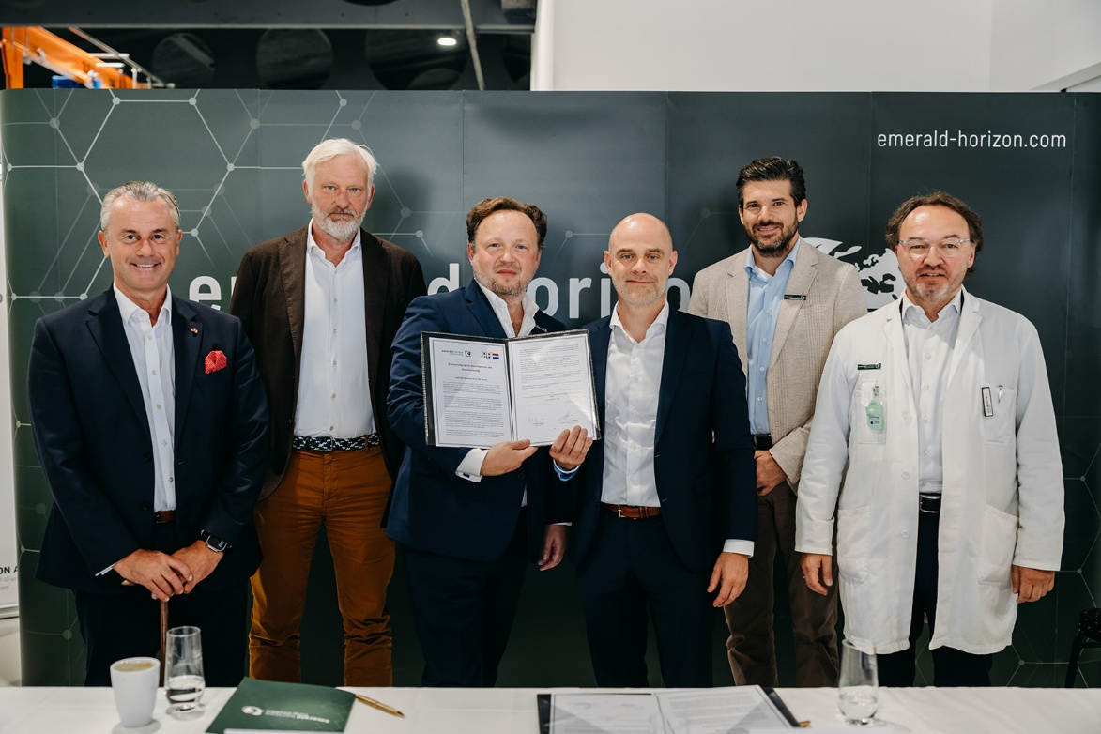
Image: (from left to right) Ing. Norbert Hofer, MBA (Emerald Horizon), Hans Priem (VDL), CEO Florian Wagner (Emerald Horizon), Markjan Vermeer (VDL), MMag. Philipp Pölzl (Emerald Horizon), DI Dr. Mario J. Müller (Emerald Horizon) © Fuchs
Free of charge for editorial use.

Media Contact
Ing. Norbert G. Hofer, MBA
Vice President Strategic Communications, Emerald Horizon AG
Email: hofer@emerald-horizon.com
Mag. Melanie Koch, MA
Media Relations, Emerald Horizon AG
Mobile: +43 664 54 55 324
Email: koch@emerald-horizon.com

 |  |  |  |  | 

